MENU LAVANDIN : 52.
Mise en bouche of the moment
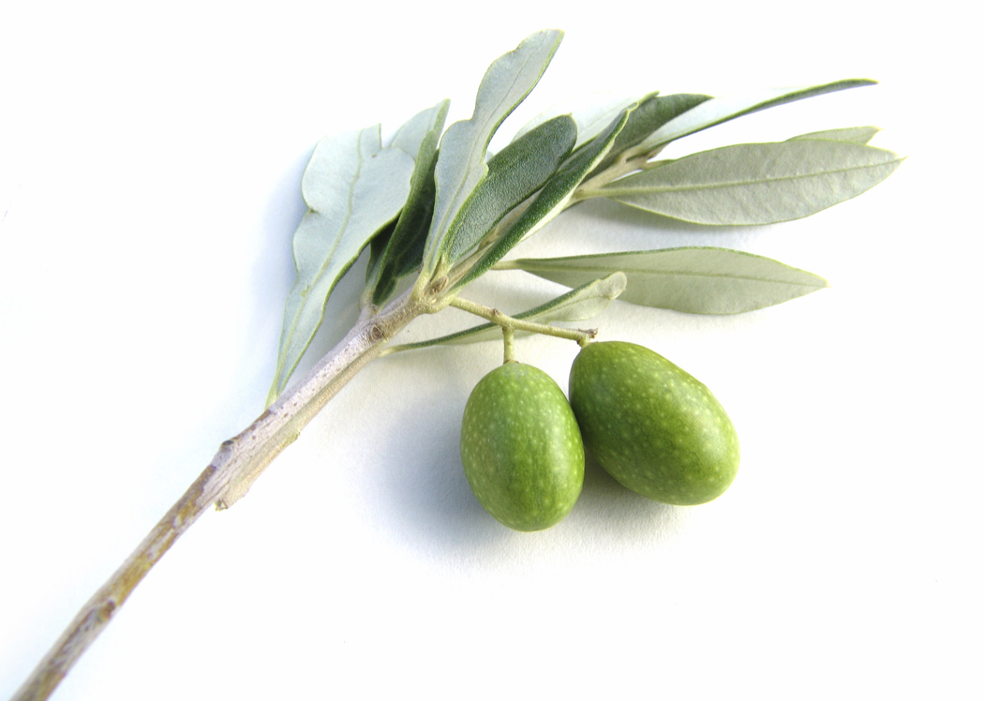
Pointes de melon en habit de jambon sec « Rougeot du Charvin » 22.
Melon tips wrapped in dry-cured ham from a prized local pork breed
OU / OR
Croustillant de savoyardises au Tamié de l'abbaye 19.
Savoyard crisp with abbey cheese from the Tamié Abbey.
Féra sauvage du lac d'Annecy (Manu CLERC) à l'oseille du jardin 26.
Wild-caught fera fish from Lake Annecy with garden sorrel
OU/ OR
Roulade d'agneau de Savoie, provençale de légumes et jus au thym citron 24.
Roulade of Savoy lamb in a lemon-thyme jus,
accompanied by Provençal vegetable medley
46 with cheese OR dessert

Any dish from the Lavandin menu can also be ordered from the main menu as well as
from the Farigoule and the Garrigue menu!
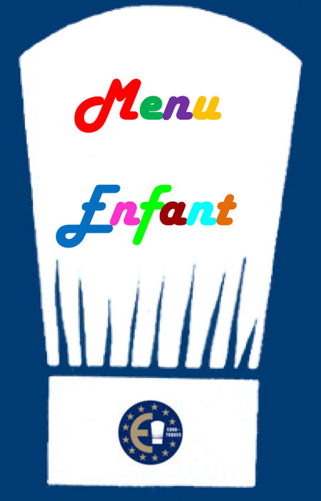 | CHILDREN'S MENU 16.  This menu is exclusively prepared with all natural fresh local produce. It contains little salt and little sugar. No chips!  Main course (meat or fish) and accompaniment + ice cream.

MENU CIGALOU : 38
Your choice of a starter from the Lavandin menu + your choice of a main course
from the Lavandin menu
OR
Your choice of a main course from the Lavandin menu and our selection of Savoy cheeses
OR
Your choice of a main course from the Lavandin menu and today’s special dessert

All our prices are net and inclusive of tax (service is included).
A full allergy list is available on request

