MENU LAVANDIN : 52.
Mise en bouche of the moment
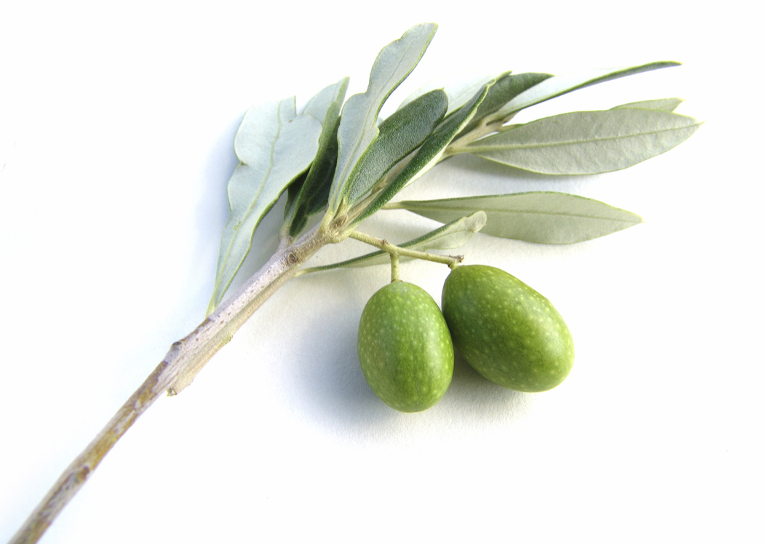
Salade d'asperges, truite fumée de Marlens roulée au chèvre frais ciboulette 22.
Asparagus salad and Marlens smoked trout roll with fresh goat cheese and chives
OU / OR
Chou farci de petits légumes, velouté de petits pois à l'ail des ours 19.
Cabbage stuffed with baby vegetables, served with a pea and ramson velouté
Féra sauvage du lac d'Annecy (Manu CLERC) à l'oseille du jardin 26.
Wild-caught fera fish from Lake Annecy, served with fresh garden sorrel
OU / OR
Filet mignon de cochon de France crème à la moutarde et poêlée d'artichauts pommes de terre 24
French pork filet mignon with mustard cream sauce, served with sautéed artichokes and potatoes
46 with cheese OR dessert

Any dish from the Lavandin menu can also be ordered from the main menu as well as
from the Farigoule and the Garrigue menu!

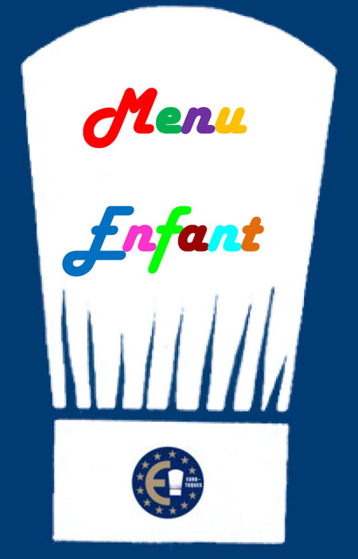 | CHILDREN'S MENU 16.  This menu is exclusively prepared with all natural fresh local produce. It contains little salt and little sugar. No chips!  Main course (meat or fish) and accompaniment + ice cream.

MENU CIGALOU : 38
Your choice of a starter from the Lavandin menu + your choice of a main course
from the Lavandin menu
OR
Your choice of a main course from the Lavandin menu and our selection of Savoy cheeses
OR
Your choice of a main course from the Lavandin menu and today’s special dessert

All our prices are net and inclusive of tax (service is included).
A full allergy list is available on request

