MENU LAVANDIN : 52.
Mise en bouche of the moment
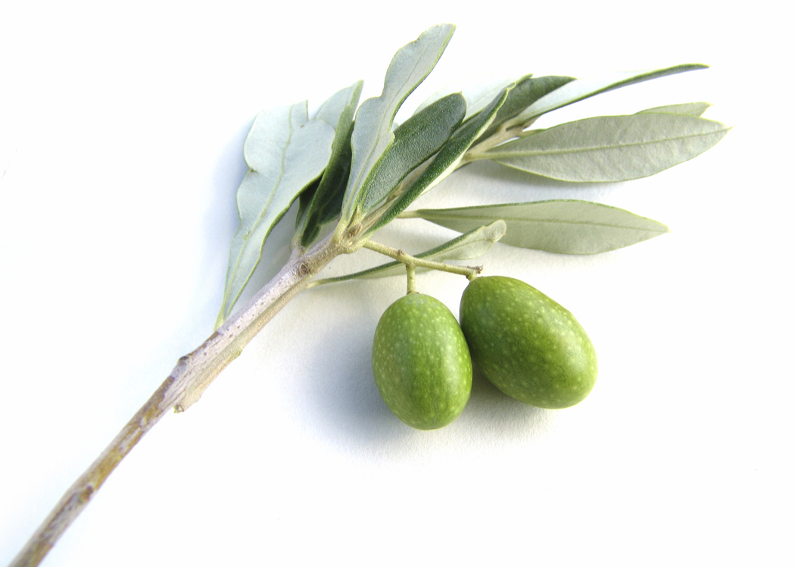
Salade au foie gras de canard et au boudin blanc doré 22.
Duck foie gras and pan-browned white pudding salad
OU / OR
Coquillettes jambon blanc et truffes 19.
Shell pasta in cooked ham and truffle cream
Sans arête de rouget barbet, purée au safran 26.
Pan-fried red mullet barbet fillets and saffron mashed potatoes
OU / OR
Paupiette de lapin fermier, topinambours aux noisettes 32.
Farm rabbit paupiette served with Jerusalem artichokes and hazelnuts

46 with cheese OR dessert

Any dish from the Lavandin menu can also be ordered from the main menu as well as
from the Farigoule and the Garrigue menu!
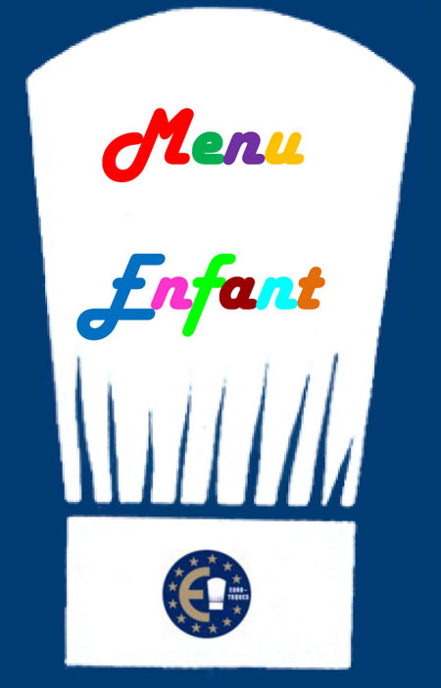 | CHILDREN'S MENU 16.  This menu is exclusively prepared with all natural fresh local produce. It contains little salt and little sugar. No chips!  Main course (meat or fish) and accompaniment + ice cream.

MENU CIGALOU : 38
Your choice of a starter from the Lavandin menu + your choice of a main course
from the Lavandin menu
OR
Your choice of a main course from the Lavandin menu and our selection of Savoy cheeses
OR
Your choice of a main course from the Lavandin menu and today’s special dessert

All our prices are net and inclusive of tax (service is included).
A full allergy list is available on request

